CNN based brain medical imaging and classification
A newly proposed system to automate the process of medical imaging using Artificial Intelligence

Aakash Varma Nadimpalli
Dept. of Electrical and Electronics
Vellore Institute of Technology, Vellore
Tamil Nadu, India
Abhilash Srivastava
Dept. of Electrical and Electronics
Vellore Institute of Technology, Vellore
Tamil Nadu, India

Abstract—The main purpose of this project is to make the medical scan examination process more efficient economically and also with respect to time. Moreover, Medicinal errors influence one of each 10 patients around the globe. Specialists took an investigation at concentrates that analysed the restorative demise rate data from 2010 to 2018 and extrapolated that in excess of 250,000 deaths for every year had begun from a helpful mix-up, which implies 9.5% of all deaths consistently alone in the US. This framework that we have proposed diminishes the odds of this human blunder caused in the field of prescription. The target of this venture or framework is to make a web application which is an entry that can be accessed freely by anybody around the globe. Honestly by making the framework open source we are intending to go past the requirements that we have now and making it available to others to both build up the framework and utilise the framework free of expense. We have received a procedure by the help of open source structures. This framework that we have proposed diminishes the odds of this human blunder caused in the field of prescription. The model proposed in this paper have gone a bit more technically advanced and computerised this procedure of distinguishing irregularities inside the cerebrum with the assistance of Artificial Intelligence.The objective of this project or system is to make a web application which is a portal that can be accessed freely by anyone around the world. The technology which has been deployed for the system to become automated by making the system learn and predicting on its own is Convolutional Neural Network.
Keywords-Automation, CT, Machine Learning, Medical Imaging, MRI, Neural Networks

Introduction
In this world there are diverse restorative imaging strategies like X-Ray scans, CT scans and MRI scans for the cerebrum to discover irregularities like Alzheimer's disease, Hemorrhage and Tumor. The usual method for finding these oddities is by getting the scans analysed by the specialists. In the project that we have proposed in this paper we have gone a bit more technically advanced and computerised this procedure of distinguishing irregularities inside the cerebrum with the assistance of Artificial Intelligence.
The objective of this project or system is to make a web application which is a portal that can be accessed freely by anyone around the world. In fact by making the system open source we are planning to go beyond the constraints that we have now and making it accessible to others to both develop the system and use the system free of cost. We have adopted a strategy by the assistance of open source structures to make this innovation free of expense and make it accessible to each individual with two different web servers. One server running on python and the other running on node JS.
Following are the advances we have utilised:
- Profound learning: we have utilised neural systems alongside Convolutional Neural Networks to concoct the indicator.
- Tensorflow: we have utilised tensorflow on GPU for completing all the numerical calculation for preparing the model.
Node.js: we have conveyed our model on the server utilising node.js and carafe.
The motivation for us to pick up this field of study for our project is listed below under three different categories:
- Human Error: Medical mistakes affect one of every 10 patients around the world. Specialists took a study at concentrates that examined the medicinal death rate information from 2010 to 2018 and extrapolated that more than 250,000 passings for each year had originated from a therapeutic mistake, which means 9.5% of all deaths every year alone in the US. This system that we have proposed decreases the chances of this human error caused in the field of medicine.
- Cost of Time: In this very busy world, people do not have the time to visit the doctors very frequently and with a personal experience, it takes a lot of days for the process of getting your scans examined by the doctors. Time gets wasted in getting appointments and a lot of other things like transferring your scan files across the doctors. So, we have proposed and planned a system that is very fast and effective.
- Diminishing visiting cost: Visiting costs of doctors is also very high. Usually it is a three step process of getting the scan, then taking the scan to a specialist to get the scan examined and get a report on it and then finally take the scan to the doctor to get the final treatment. And all these processes involve spending a lot of money. Where as the proposed idea is just a two step process of uploading the scans and get the results, then u can consult whatever doctor or specialist you want to get the treatment done.

System Overview

Web architecture model
The Model proposed for this project consists of two different servers running on different ports where one server is running on JavaScript which connects the user to the backend of the system with the help of a user computer interaction interface. The other server will run on Python which is the backbone for the Convolution Neural Networks and detects the abnormalities associated to the scan inputted. Whenever any Scan image is given to the Web interface form, this stores the image in the database and the address along with a few image details are stored as metadata of the image in the database. Whenever submit button is clicked by the user, the API of a success key is sent to the python server. This server will respond by extracting the metadata of the image. This extracted metadata of the image has the location where the image is stored in the server. This image is then processed in the python server, with the help of a few image processing algorithms. We have used the library called PIL (pillow) for processing the image. This processed image is sent as a numpy array to the model. The model is loaded into the server and the numpy array is processed with it.
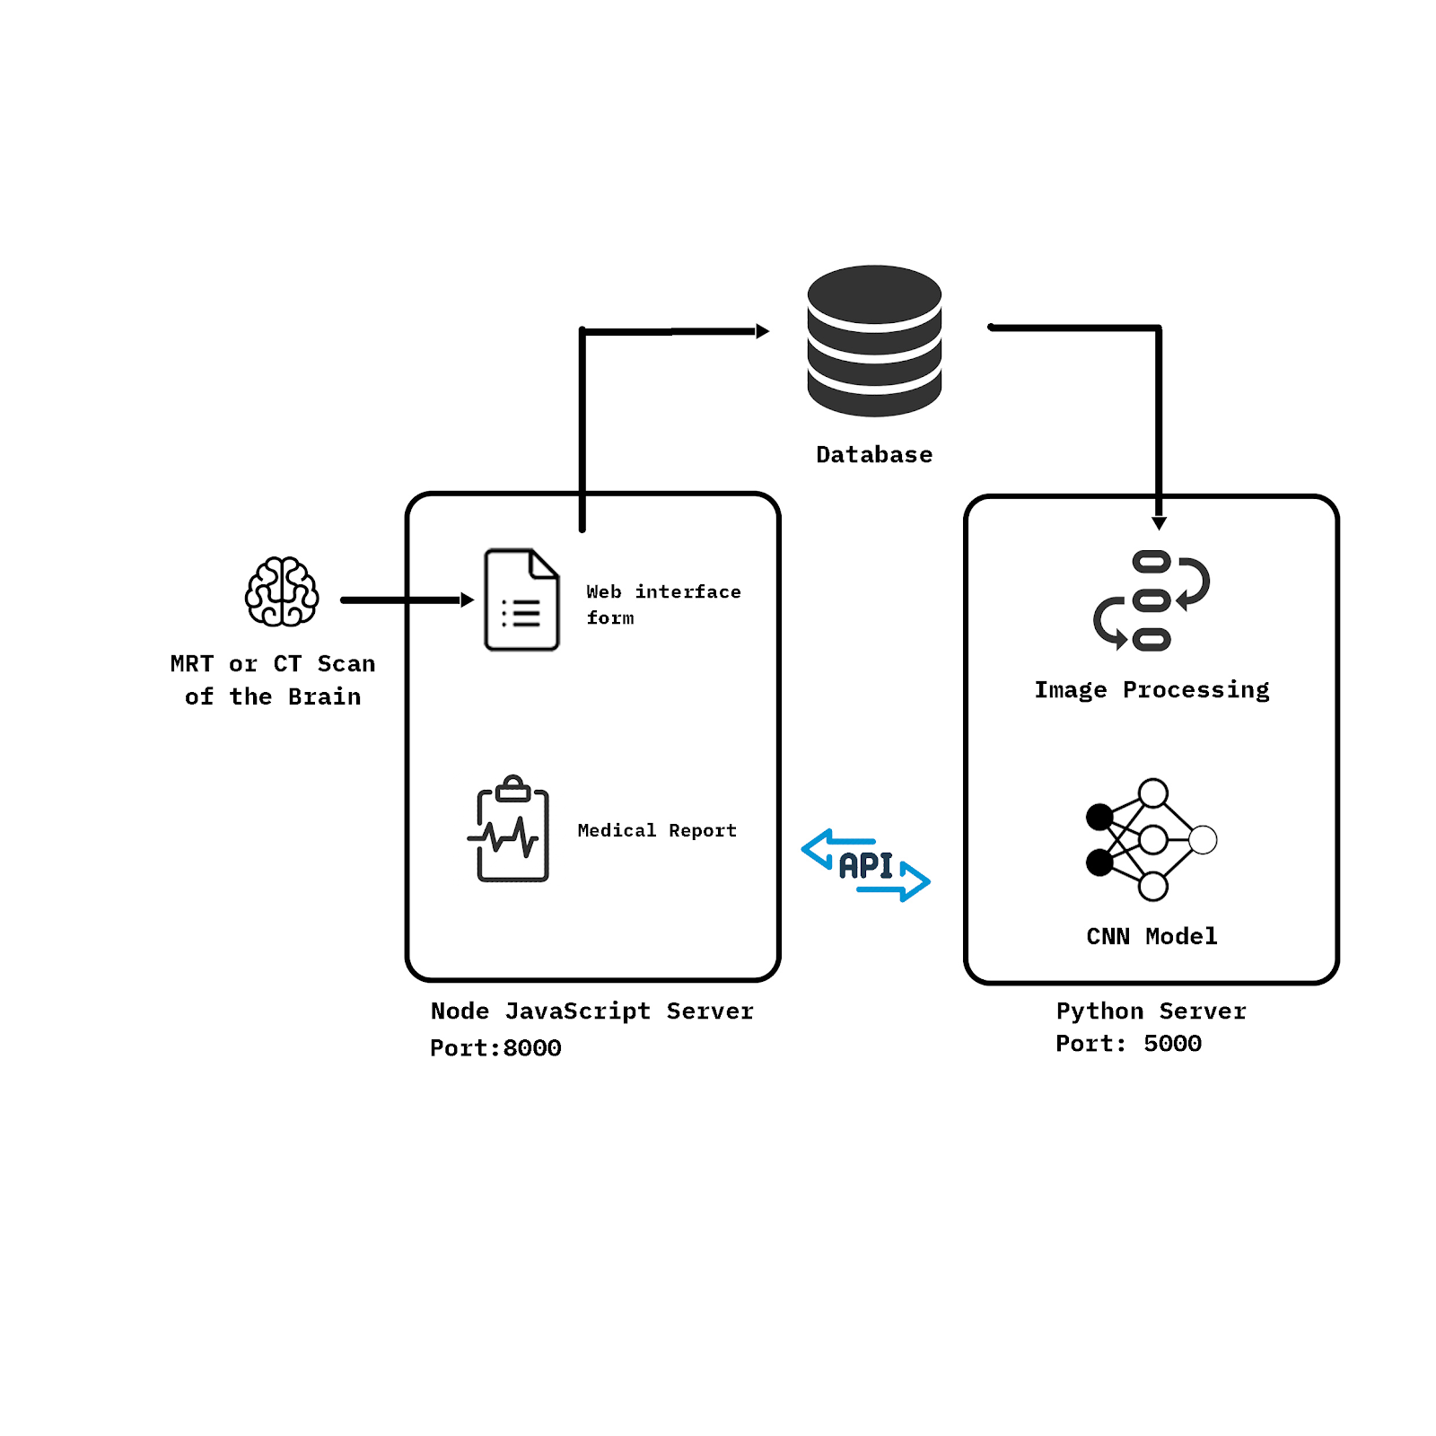
Figure 1. Block diagram of Web Interface Architecture

Convolution Neural Networks model
In neural systems, Convolutional neural network (ConvNets or CNNs) is one of the primary classes to do pictures acknowledgment, pictures orders.Object detection, recognising faces and so on., are a portion of the zones where CNNs are broadly utilised. In light of the picture resolutions, it will see h x w x d (where h :Stature, w:Width, d : Measurement). In fact, deep learning CNN models to train and test, each i/p picture will go it through a progression of convolution layers with filters (Kernels), Pooling, completely associated layers (FC) and apply Softmax capacity to order an object with probabilistic qualities somewhere in the range of 0 and 1. The underneath figure is a finished stream of CNN to process an i/p picture and groups the items dependent on qualities.
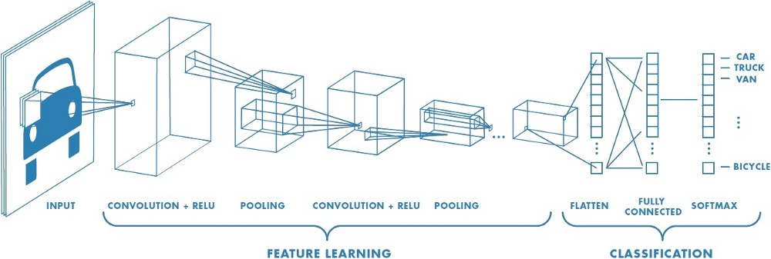
Figure 2. Convolutional layers of CNN
In CNN, Convolution is the first layer to extricate highlights(features) from an input picture. Convolution safeguards the connection between pixels by learning picture highlights utilising little squares of input information. It is a numerical task that takes two data sources, for example, picture matrix and a filter or kernel.
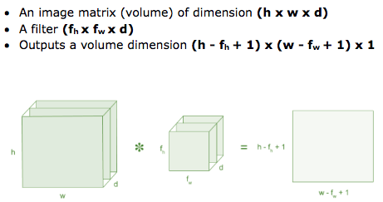
Figure 3. Image volume of a CNN model.
Consider a 5 x 5 whose image pixel values are 0, 1 and filter matrix 3 x 3 as shown in below
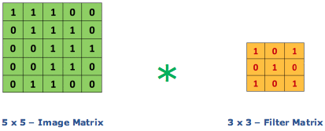
Figure 3. Segmented image of a CNN input
At that point the convolution of 5 x 5 picture lattice multiplies with 3 x 3 filter grid which is classified "feature map" as yield appeared beneath. Convolution of a picture with various filters can perform tasks, for example, edge identification, obscure and done by applying filters. The underneath precedent shows different convolution picture in the wake of applying distinctive kinds of filters (kernels).
Strides: Stride is the quantity of pixels moves over the input matrix. At the point when the stride is 1 then we move the filters to 1 pixel at any given moment. At the point when the stride is 2 then we move the filters to 2 pixels at any given moment, etc. The underneath figure indicates convolution would work with a walk of 2.
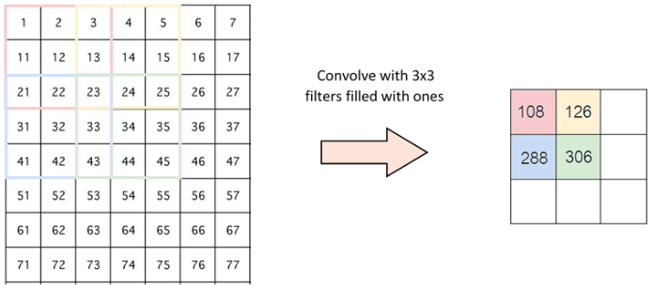
Figure 4. Strides moving over the image in a CNN architecture.
Padding: Now and then filters does not flawlessly fit the input picture. We have two choices:
- Cushion the image with zeros (zero-cushioning) so it fits.
- Drop the piece of the picture where the filter did not fit. This is called valid padding which keeps just a substantial piece of the picture.
Non Linearity (ReLU) :ReLU represents Rectified linear Unit for a non-linear operation. The yield is ƒ(x) = max(0,x). Why ReLU is imperative: ReLU's motivation is to present non-linearity in our ConvNet. Since this present reality information would need our ConvNet to learn would be non-negative linear qualities.
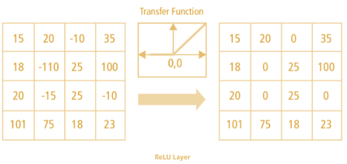
Figure. 5 transfer function
There are other nonlinear functions, for example, tanh or sigmoid can likewise be utilised rather than ReLU. The majority of the information researchers utilises ReLU since execution insightful ReLU is superior to the other two.
Pooling Layer: Pooling layers area would lessen the number of parameters when the pictures are excessively huge. Spatial pooling additionally called subsampling or downsampling which decreases the dimensionality of each guide yet holds the essential data. Spatial pooling can be of various kinds:
- Max Pooling
- Average Pooling
- Sum Pooling
Max pooling take the biggest component from the amended feature map. Taking the biggest component could likewise take the average pooling. An aggregate of all components in the feature map called as sum pooling.
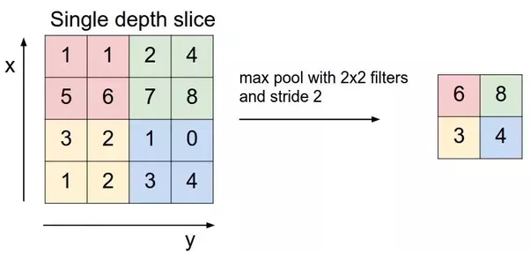
Figure 6. Maxpooling
Fully Connected Layer: The layer which is known as FC layer, we Flatten our framework into vector and feed it into a completely associated layer like neural network.
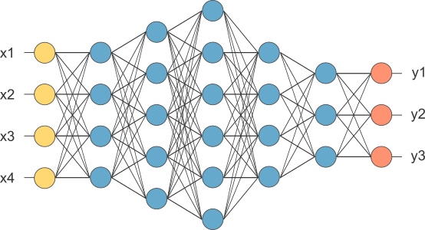
Figure 6. Fully connected convolutional layers.
In the above diagram, include map grid will be changed over as vector (x1, x2, x3, … ). With the completely associated layers, we consolidated these features together to make a model. At long last, we have an activation function, for example, softmax or sigmoid to arrange the yields as feline, hound, vehicle, truck and so on.

Model Architectures
The system that we have proposed in this system consists of three models of Alzheimer’s, brain tumor and hemorrhage.

Model architecture of Alzheimer’s disease:
Before going for selecting the model for the Alzheimer’s disease it is important to analyse the data present in the dataset. This process is called exploratory data analytics. The following are the analytics done on the data. this analysis gives a better insight of what features to consider and what features not to consider in preparing the model.
In this segment, we have concentrated on investigating the connection between each element of MRI tests and dementia of the patient. The reason we led this Exploratory Data Analysis process is to express the relationship of information unequivocally through a chart with the goal that we could accept the connections before information extraction or information investigation. It may assist us with understanding the idea of the information and to choose the proper examination technique for the model later.

Table 1. Data-points sample in the dataset of Alzheimer’s disease
The graph below, as shown in Fig. 7, depicts the comparison of Dementialted patients based on the gender. Here 0 - Male and 1 - Female. We can see that, under the demented category, the graph of Male is higher than the graph of female and in the non-demented part, the graph of female is higher than the graph of male. Thus, this graph implies that men are more likely with dementia than women.
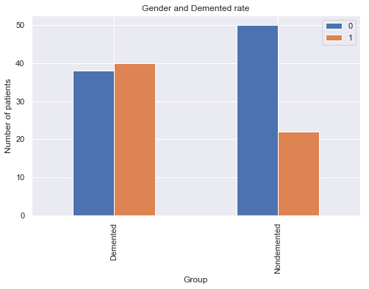
Figure. 7 Gender based Dementia analytics
Comparison of MMSE (Mini Mental State Examination) with Demented and Non-Demented groups have shown from the below graph that Non-Demented group of people are likely to get higher MMSE test results compared to the Demented group. In the below graph, Non-Demented is 0 and Demented is 1.
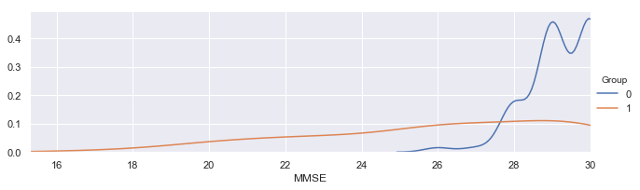
Figure. 8 Gender vs MMSE Dementia analytics
The following three graphs, as shown in Fig. 9, 10 and 11 are comparison of ASF (Atlas Scaling Factor), eTIV (Estimated Total Intracranial Volume) and nWBV (Nominal Whole Brain Volume) with the Demented and Non-Demented groups. From the following graphs, we can infer that, Non-demented aggregate has higher mind volume proportion than Demented aggregate. This is thought to be on the grounds that the illness influence the mind to recoil its tissue.
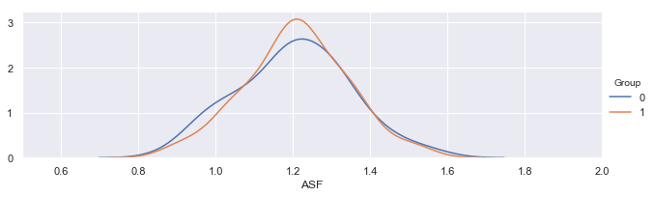
Figure. 9 Gender vs ASF Dementia analytics
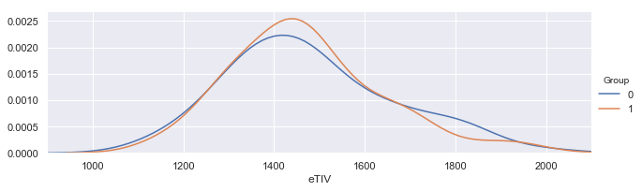
Figure. 10 Gender vs eTIV Dementia analytics
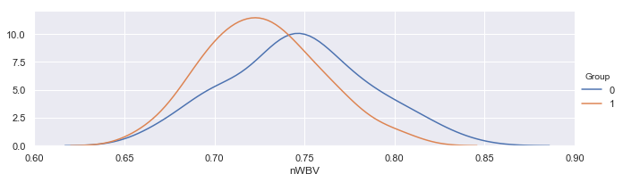
Figure. 11 Gender vs nWBV Dementia analytics
The following graph, as shown in Fig. 12, is the comparison of AGE with the Demented and Non-Demented groups. From the following graphs we can infer that, there is a higher convergence of 70-80 years of age in the Demented patient gathering than those in the non-demented patients. We surmise patients who experienced that sort of sickness has lower survival rate so that there are a couple of 90 years of age
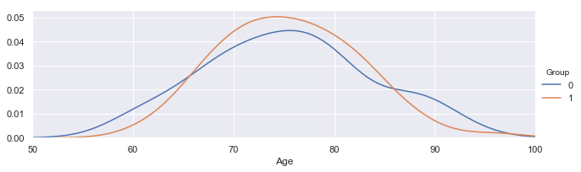
Figure. 12 Gender vs Age Dementia analytics

Data Analytics intermediate result summary:
- Men are almost certain with dementia, an Alzheimer's Disease, than Women.
- Demented patients were less educated as far as long stretches of education.
- Non-demented bunch has higher mind volume than Demented gathering.
- Higher convergence of 70-80 years of age in Demented gathering than those in the non-demented patients.
The model architecture of Alzheimer’s consists of a machine learning model with different types of classifiers like, logistic regression[11] , decision trees, SVM[1][8] and Random forest[9] to predict the Alzheimer’s output. But we have to finally consider only one model for prediction. Therefore we have taken into consideration the accuracies of different classifiers and picked the best model among them. The table, as shown in Table. 3, the results of the accuracies of the ML models.
Table. 3 Accuracies of the Machine Learning models.

Model architecture of Hemorrhage:
CNN: Two structures were advanced, initial one included thirty two Convolutional layers with two max pooling layers of size 2 and finished with "relu" activation function[6]. This model was great with exceptionally less overfitting[5] however there was a medicinal issue with it, which is clarified in "false negative outcome" underneath. In this manner, the model was moved up to sixty-four layer profundity and subsequently, we got a precision increment with it[3]. The enhancer which is utilised for the incorporating some portion of the CNN layers is rmsprop[2].
Interconnected neural system: This piece of architecture incorporates the neural system which is completely interconnected with every node in the model. It comprises of 64 nodes in the primary layer and with each having an activation function set to relu[7]. This layer is associated with another layer comprising of nodes with activation function set to sigmoid so just two yields are conceivable o or 1 that is either yes or no. False negative outcome will kill patient.False positive outcome will be a bother. We needed to rebuff false negative outcomes while preparing the model. Rebuffing false negatives might be executed in a few different ways.
- lopsidedness dataset so there are increasingly positive cases, hence model will incline toward false positives over false negatives
- make it a multi-class classification and use 'class_weight' parameter of Keras (which is basically will do a similar trap).
- compose custom loss function that is arranged on bringing down false negative rate (or improving affect-ability) or on the other hand compose custom measurements, in view of which checkpoint will save model.

Model architecture of Tumor:
CNN: Two architectures were evolved, first one included thirty two Convolutional layers with two max pooling layers of size 2 and done with “relu” activation function[6]. This model was good with very less overfitting[5]. The optimiser which is used for the compiling part of the CNN layers is Adam[4][10] in this case.
Interconnected neural networks: This part of architecture includes the neural network which are fully interconnected with each node in the model. It consist of 64 nodes in the first layer and with each having an activation function set to relu[7]. This layer is connected to another layer consisting of nodes with activation function set to sigmoid so that only two outputs are possible o or 1 that is either yes or no.

System Demonstration
The project consists of a Web Interface which is open for all patients to upload their scans.
Step 1. Open the Web application. Here we will open the web application by going to the localhost: 8000 since the application is not hosted on the remote server. The local server running on the computer present right now is port number 8000.
Step 2. Click on “get started” to start the web application, as shown in Fig. 13.
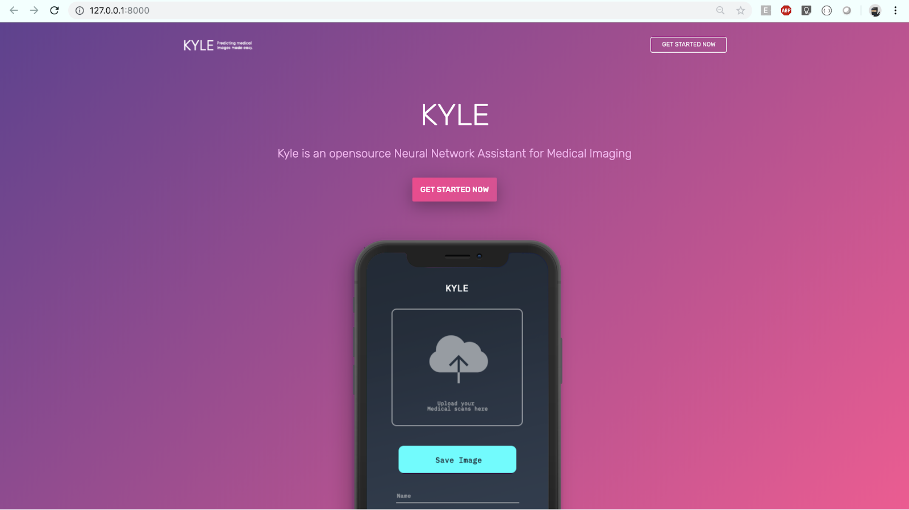
Figure. 13 Web application landing page.
Step 3. A form opens to fill in the personal details, as shown in Fig. 14, and to upload the scans. The details include personal details like name, age, etc. and the other information like Scan details etc. After filling in those details and uploading the scans click on the “Submit” button to go to the next.
Step 4. It might take some time to open the page that will generate the medical report because the machine learning or the deep learning CNN model has to be loaded in the server and the frontend has to wait for the request to return back to it.

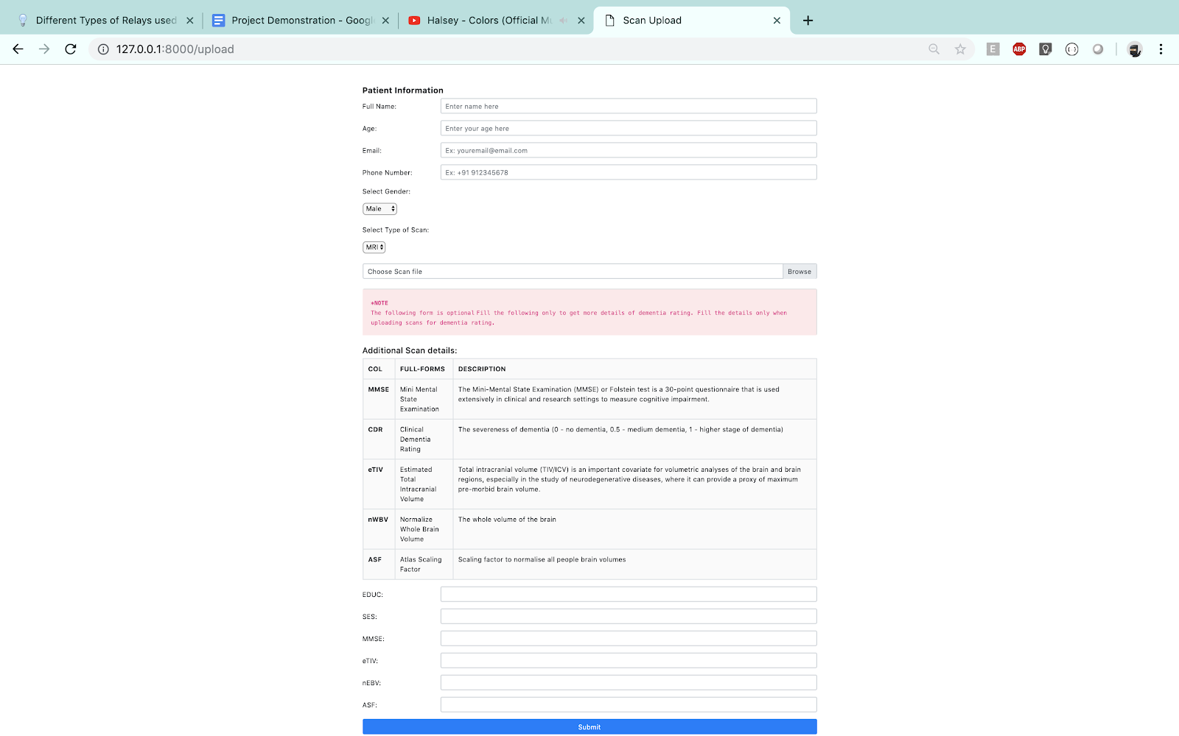
Figure. 14 Web application form page to upload the details and Scans.
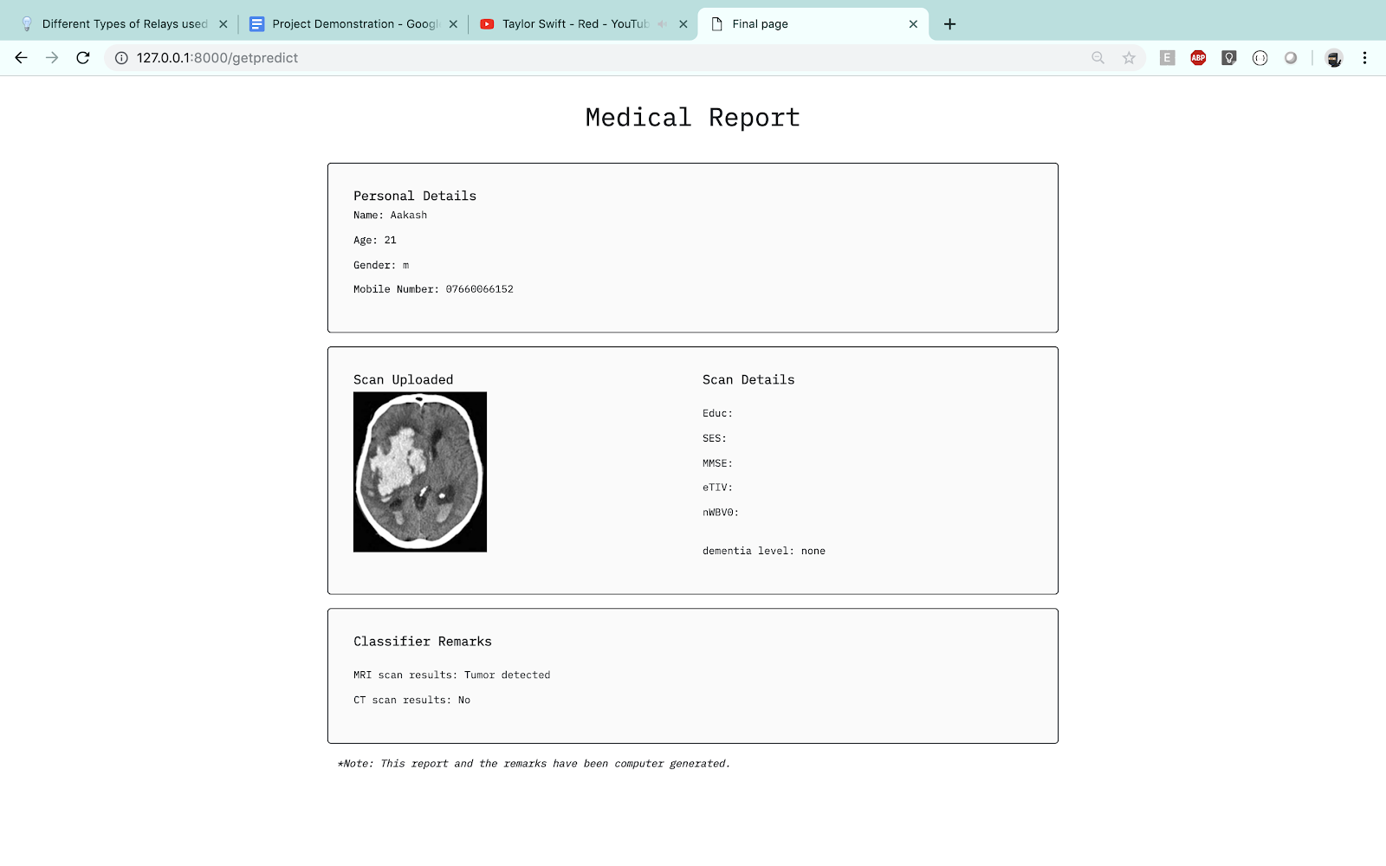
Figure. 15 Web application final medical report.
Step 5. Finally we get a generated medical form showing the details of the scan outputs and intimidating you about the possible disease that u can have depending on the scans you have uploaded.

Results
Machine Learning model for Alzheimer’s results: From the table, as shown in Table. 4, we can conclude that the Decision Tree model has the best training and testing accuracy and hence we have gone forward by using this model in the backend application of this project to detect Alzheimer’s disease.
Table. 4 Machine Learning model for Alzheimer’s results
CNN model of Hemorrhage results: From the table, as shown in Table. 5, shows that the accuracy of 64 layer CNN model is more than the 32 layer CNN model. Therefore, we have selected the 64 layer model for the Backend of the system.
Table. 5 Deep Learning CNN model for Hemorrhage results
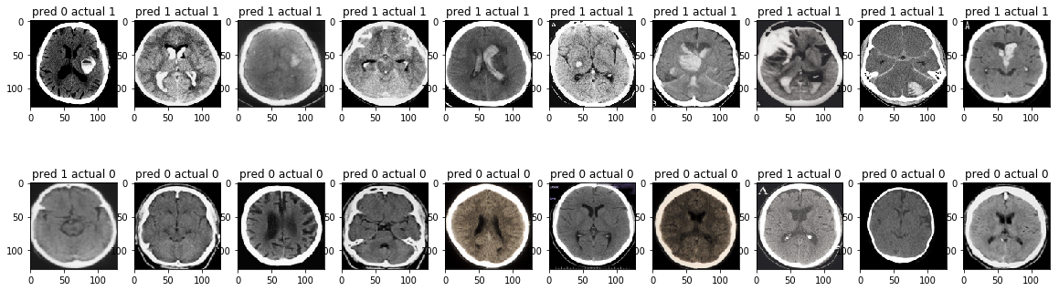Figure. 16 Result of hemorrhage model
CNN model of Tumor results: We have used a 32 layer CNN model to detect tumor and we have used the same model in the backend of the system.
Table. 6 Deep Learning CNN model for Tumor results

Acknowledgment
This Project was supported by Vellore Institute of Technology University. We are thankful to our project mentor Ruban N who provided expertise that greatly assisted the project. We are also grateful to Prof. Ruban N for assistance with Medical Imaging techniques, and Prof. Mahalakshmi P who moderated this project and in that line improved the manuscript significantly. We are also immensely grateful to lab faculty staff for helping us and providing assistance with the facility to work with this project.

References

[1] 1NP, K.T. and Varghese, D., 2018, May. A Novel Approach for Diagnosing Alzheimer's Disease Using SVM. In 2018 2nd International Conference on Trends in Electronics and Informatics (ICOEI) (pp. 895-898). IEEE.
[2] Hussain, S., Anwar, S.M. and Majid, M., 2018. Segmentation of glioma tumors in brain using deep convolutional neural network. Neurocomputing, 282, pp.248-261.
[3] Gao, X.W. and Hui, R., 2016, July. A deep learning based approach to classification of CT brain images. In 2016 SAI Computing Conference (SAI) (pp. 28-31). IEEE.
[4] Dong, H., Yang, G., Liu, F., Mo, Y. and Guo, Y., 2017, July. Automatic brain tumor detection and segmentation using U-Net based fully convolutional networks. In annual conference on medical image understanding and analysis (pp. 506-517). Springer, Cham.
[5] Zikic, D., Ioannou, Y., Brown, M. and Criminisi, A., 2014. Segmentation of brain tumor tissues with convolutional neural networks. Proceedings MICCAI-BRATS, pp.36-39
[6] Akkus, Z., Galimzianova, A., Hoogi, A., Rubin, D.L. and Erickson, B.J., 2017. Deep learning for brain MRI segmentation: state of the art and future directions. Journal of digital imaging, 30(4), pp.449-459.
[7[ Wang, S.H., Phillips, P., Sui, Y., Liu, B., Yang, M. and Cheng, H., 2018. Classification of Alzheimer’s disease based on eight-layer convolutional neural network with leaky rectified linear unit and max pooling. Journal of medical systems, 42(5), p.85.
[8] Mahapatra, D., Schueffler, P., Tielbeek, J.A., Buhmann, J.M. and Vos, F.M., 2012, October. A supervised learning based approach to detect crohn’s disease in abdominal mr volumes. In International MICCAI Workshop on Computational and Clinical Challenges in Abdominal Imaging (pp. 97-106). Springer, Berlin, Heidelberg.
[9] Zikic, D., Glocker, B., Konukoglu, E., Criminisi, A., Demiralp, C., Shotton, J., Thomas, O.M., Das, T., Jena, R. and Price, S.J., 2012, October. Decision forests for tissue-specific segmentation of high-grade gliomas in multi-channel MR. In International Conference on Medical Image Computing and Computer-Assisted Intervention (pp. 369-376). Springer, Berlin, Heidelberg.
[10] Patel, A. and Manniesing, R., 2018, February. A convolutional neural network for intracranial hemorrhage detection in non-contrast CT. In Medical Imaging 2018: Computer-Aided Diagnosis (Vol. 10575, p. 105751B). International Society for Optics and Photonics.
[11] Valcour, V.G., Masaki, K.H., Curb, J.D. and Blanchette, P.L., 2000. The detection of dementia in the primary care setting. Archives of internal medicine, 160(19), pp.2964-2968.

